Burrowes State School

Instrumental Music
Handbook

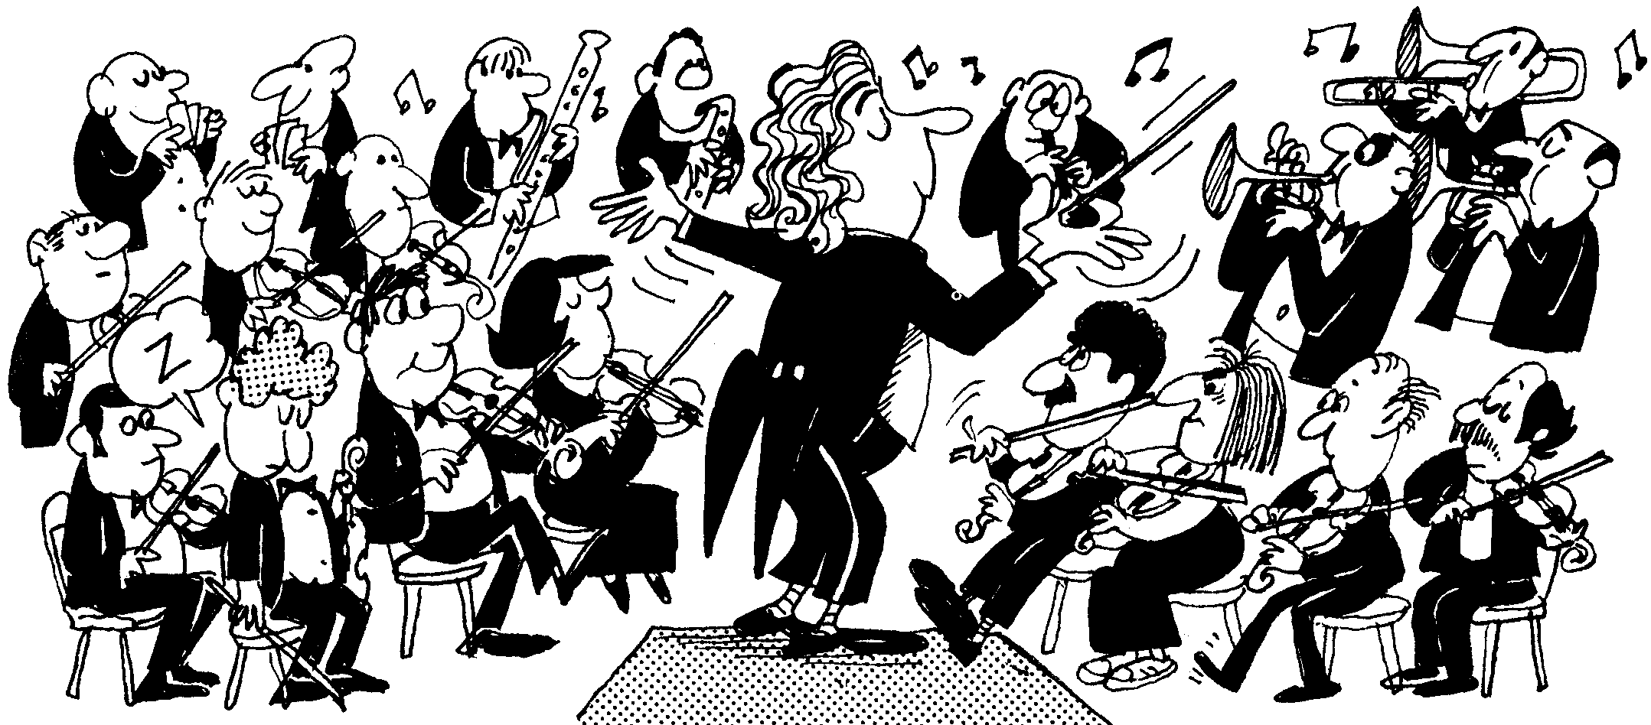

All enquiries can be emailed to
instrumentalmusic@burrowesss.eq.edu.au

Contents
Opportunity 4
From the Curriculum 4
Student Selection 5
Commitment 6
Expectations 6
Forms, Fees and Communication 7
Home Practice 8
Instrument Hire 9
Books and Accessories 10
String Students 10
Year 3 10
Year 4 10
Year 5 10
Year 6 10
Band Students 11
Flute 11
Clarinet/Bass Clarinet 11
Alto/Tenor Saxophone 11
Trumpet 11
Trombone 11
French Horn 12
Percussion 12
Music Shops 13

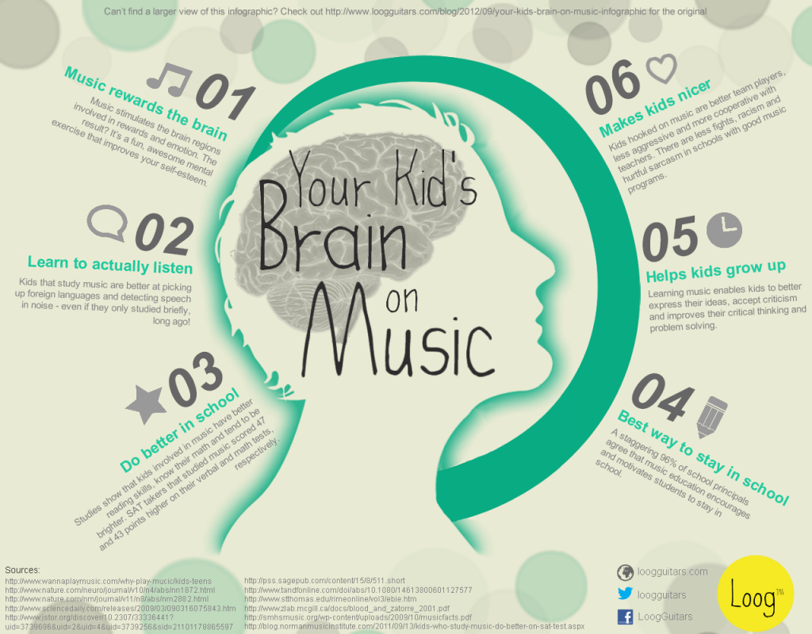

Instrumental Music @

Burrowes State School

Opportunity
Why learn an instrument?
Learning an instrument makes our brain bigger. It helps us with reading and comprehension skills, problem solving skills and improves our capacity to work in a team.
It uses the whole brain unlike any other learning activity.
The Queensland Instrumental Music Program is an ensemble-based music program, meaning that students learn to play together from the very first lesson.
Students participate in one 30 minute group Lesson, and one Ensemble/Orchestra rehearsal, per week. Lessons take place during school hours while Ensemble/Orchestra rehearsals are either before school or during play time.
Progression through the Instrumental Music Curriculum occurs through both lessons and ensemble, with students developing a range of skills both on and off the instrument. Assessment takes place each term with report card marks provided each semester.

From the Curriculum
“Music is a unique and integral part of life. It has the capacity to inspire all students’ creativity and imagination, engage them in the art of expression, immerse them in a language and history that is rich in culture, provide them with opportunities beyond the classroom and excite them about life and learning.
The skills, concepts and attitudes that students acquire as a result of music education benefit them not only during their schooling but also in the years beyond, whatever their chosen career path. The overarching purpose of the co‐curricular Instrumental Music Program is to provide students with the opportunity to become musicians and experience the expressive qualities of music through learning to play a band or orchestral instrument and to participate in performance ensembles such as concert bands and orchestras.”

Student Selection
The Instrumental Music program is first and foremost an ensemble based program. Students play together in groups from the very beginning.
As such, a limited number of each instrument is offered, and students don’t always receive their first preference for an instrument.
After an expression of interest is received, our Instrumental Music Teachers will liaise with the student’s Classroom Music Teacher and check on their previous report card grades. The purpose of this is to ensure the student is able to keep up with their school work once they have started studying their instrument. The Teachers will also look at the student’s record of positive behaviour. They may also request information from the parent or caregiver regarding the family’s ability to transport large instruments to and from school, and provide a space for home practice.
The Instrumental Music Teachers will then test the student with different types of mouthpieces/instruments to see what they would be suited to, and following this an offer may be extended to the family.
If space allows some negotiations can be made to change instruments after one year of learning, however please keep in mind that this option is only offered in exceptional circumstances – for example, if a high-achieving student wishes to learn the double bass after one year of playing violin, or a Teacher offering a student a place on trombone if there are not enough trombones in the orchestra. Students are not permitted to change instruments without approval from the Instrumental Music Teachers.

Commitment
Students learning in the Instrumental Music Program are expected to continue throughout primary school, and through to the end of each year. Being an ensemble program, every team member plays an important role. Just as in sport, every team member turns up to the match and contributes.
Students must attend lessons and rehearsals every week, unless they have an exam or an excursion.
Every student has one group lesson on a rotating timetable during school hours, and one ensemble rehearsal either before school or during one of the breaks.
Students wishing to leave the program are required to get approval by the Instrumental Music Teacher and provide a signed note.
Students who have withdrawn from the program may apply to re-enter. Re-entry is at the discretion of the Instrumental Music Teacher in consultation with the Deputy Principal.
Students are also expected to adhere to the school’s Behaviour Policy and any causes for concern will be discussed with the Deputy Principal.

Expectations
Students are expected to:
- Practice at home at least five times each week
- Look after their hire instrument with the utmost care
- Check the lesson timetable every week
- Bring all required equipment each week to their lesson and rehearsal
- Attend all lessons, rehearsals and performances
Parents/Caregivers are expected to:
- Make full payment or initiate a payment plan of the Levy and Hire Fee made by the end of Term 1
- Ensure the email address held by the school is correct to receive regular updates
- Return permission forms by the date provided
- Support the student to practice at home, the same as would be expected for homework
- Provide students with the correct Method Book and accessories (see page 9)

Forms, Fees and Communication
All students in the Instrumental Music Program are required to pay a $20 non-refundable levy per year.
Students hiring an instrument are required to pay an additional $50 hire fee.
All fees are due by the end of Term 1, with an invoice being issued during Term 1. Payment plans are available and payment can be made at the office or online. Students are withdrawn from the program if their fees are overdue.

Annual Fees
Students participating and hiring an instrument:
$20 Levy + $50 Hire Fee = $70 invoice

Students participating with their own instrument:
$20 Levy only = $20 invoice

All students are required to return an EQ11 Hire Form (if hiring an instrument from the school) and a Student Resource Scheme Participation Agreement Form, with all sections signed. This is a legal requirement. Email your child’s Teacher at instrumentalmusic@burrowesss.eq.edu.au if you require a new copy of the forms. These will be distributed in lessons.

All forms must be returned and fees paid before an instrument can be taken home.
Our Instrumental Music Teachers communicate via email, letter and newsletter. Please ensure you have provided the school with a current email address.

Home Practice
Practice takes many forms. It could look like:
- Playing through the difficult parts of the music
- Playing and memorizing a scale or piece of music
- Trying to play a piece all the way through without stopping
- Trying to play the bits which keep making the student stop!
- Performing for a family member or friend
- Writing or making up music
Practice should occur:
- As frequently as possible – short sessions multiple times per week, rather than long sessions occasionally
- In a quiet space with a sturdy chair (such as a dining chair) and a music stand
- As part of a regular home routine
- With plenty of gentle encouragement!
Students may receive a practice chart to fill out as part of their assessment. Please ensure it is signed where appropriate by the parent/caregiver, or a close family member over the age of 18.

Instrument Hire
Hire periods for school instruments vary depending on the size of the instrument and the cost to purchase one new.
Each instrument must be returned at the end of the year and if eligible, loaned out again at the start of the next year.

Violin and viola | Maximum 1 year
Cello | Maximum 2 years
Double bass | Available to loan each year, subject to availability
Flute | Maximum 1 year
Clarinet | Maximum 1 year
Alto Saxophone | Maximum 1 year
Tenor Saxophone | Available to loan each year, subject to availability
Bass Clarinet | Available to loan each year, subject to availability
Trumpet | Maximum 1 year
French Horn | Available to loan each year, subject to availability
Trombone | Available to loan each year, subject to availability
Percussion | Instruments are kept at school

Books and Accessories

String Students
All students are required to provide their own accessories for their instrument, as follows:
Year 3
- "Sound Innovations" Book 1 (for your string instrument)
- Adjustable Music Stand (for home practice)
Year 4
- "Sound Innovations" Book 1 (for your string instrument)
- Your own instrument (violins and violas only)
- Adjustable Music Stand (for home practice)
- Rosin (for your selected string instrument)
- Shoulder Rest (Violins and Violas only)
- Rock stop/black hole (Cellos and Basses only)
- Spare set of strings
- Soft cleaning cloth (such as an unused microfibre cleaning cloth)

Year 5
- "Sound Innovations" Book 2 (for your string instrument)
- Your own instrument (violins and violas, and cellos if possible)
- Adjustable Music Stand (for home practice)
- Rosin (for your selected string instrument)
- Shoulder Rest (Violins and Violas only)
- Rock stop/black hole (Cellos and Basses only)
- Spare set of strings
- Soft cleaning cloth (such as an unused microfibre cleaning cloth)

Year 6
- "Sound Innovations" Book 2 (for your string instrument)
- Your own instrument (violins and violas, and cellos if possible)
- Adjustable Music Stand (for home practice)
- Rosin (for your selected string instrument)
- Shoulder Rest (Violins and Violas only)
- Rock stop/black hole (Cellos and Basses only)
- Spare set of strings
- Soft cleaning cloth (such as an unused microfibre cleaning cloth)

Band Students

Flute
- Sound Innovations Book 1
- Cleaning Rod
- Cleaning Cloth
- Large Handkerchief
- Adjustable Music Stand (for home practice)

Clarinet/Bass Clarinet
- Sound Innovations Book 1
- 4 Bb Clarinet/ Bass Clarinet Reeds, size 2.5
- Thumb Cushion
- Mouthpiece Brush
- Bb Clarinet Pull-Through Cleaning Cloth
- Cork Crease (lipstick type)
- Adjustable Music Stand (for home practice)

Alto/Tenor Saxophone
- Sound Innovations Book 1
- 4 Alto/Tenor Saxophone Reeds, size 2.5
- Mouthpiece Brush
- Alto/Tenor Sax Pull-Through Cleaning Cloth
- Cork Crease (lipstick type)
- Adjustable Music Stand (for home practice)

Trumpet
- Sound Innovations Book 1
- Valve Oil
- Mouthpiece Brush
- Flex Brush Bore Cleaner – vinyl coated
- Tuning Slide Grease
- Polishing Cloth (Lacquer)
- Adjustable Music Stand (for home practice)

Trombone
- Sound Innovations Book 1
- Mouthpiece Brush
- Flex Brush Bore Cleaner – vinyl coated
- Tuning Slide Grease
- Trombone Slide Cream/Oil
- Spray Bottle
- Polishing Cloth (Lacquer)
- Adjustable Music Stand (for home practice)

French Horn
- Sound Innovations Book 1
- Rotor Oil
- Mouthpiece Brush
- Tuning Slide Grease
- Polishing Cloth (Lacquer)
- Adjustable Music Stand (for home practice)

Percussion
- Sound Innovations Book 1
- Drumstick, size 7A (wood or nylon tip)
- Practice Pad – 8”
- Adjustable Music Stand (for home practice)

Music Shops
All Strings and Band instruments and the above accessories can be purchased from the following music stores or at your preferred music shop.
Please do not purchase new instruments from eBay or Aldi, as these are very likely to be poor quality and unsuitable for this program.

Music Spot  129 Browns Plains Road, Browns Plains, QLD 4118  (07) 3800 5229  https://www.musicspot.com.au | Simply for Strings  78 Enoggera Tce, Red Hill, 4059  1300 739 293  www.simplyforstrings.com.au
Vivace Music  Shop 8/62 Pinelands Rd.,  Sunnybank Hills, QLD 4109  (07) 3344 1880  http://www.vivacemusic.com.au | Animato Strings  789 Kingsford Smith Drive, Eagle Farm, 4009  1300 739 777  www.animato.com.au
Music Creators  1, 2770 Logan Road, Underwood, QLD 4119  0468 756 998  https://www.musiccreatorsonline.com.au | Music Express  2048 Logan Road, Upper Mt Gravatt, QLD 4122  (07) 3849 7088  https://www.musicexpress.com.au/

N.B. When considering purchasing your own instrument, we advise you shop around for the best price for both new and second-hand instruments. Many stores have various payment plans and rental options on all instruments. If in doubt please speak to your child’s Teacher.

